**ADAPTIVE WORK MANAGEMENT APPLICATION FOR ELEVATED PRODUCTIVITY**

**SE ZG628T: Dissertation**

By

PAVITHRA S

2022MT93172

**Dissertation work carried out at**

**Propel** **Technology Solutions, Chennai, Tamil Nadu 600116**



**BIRLA INSTITUTE OF TECHNOLOGY & SCIENCE**

**PILANI (RAJASTHAN)**

April 2024

**ADAPTIVE WORK MANAGEMENT APPLICATION FOR ELEVATED PRODUCTIVITY**

**SE ZG628T: Dissertation**

By

PAVITHRA S

2022MT93172

**Dissertation work carried out at**

**Propel** **Technology Solutions, Chennai, Tamil Nadu 600116**

Submitted in partial fulfillment of **M.Tech. Software Engineering** degree programme

Under the Supervision of

**<Supervisor Name>, <Designation>**

**Propel Technology Solutions, Chennai, Tamil Nadu 600116**



**BIRLA INSTITUTE OF TECHNOLOGY & SCIENCE**

**PILANI (RAJASTHAN)**

April 2024

**CERTIFICATE**

This is to certify that the Dissertation entitled **ADAPTIVE WORK MANAGEMENT APPLICATION FOR ELEVATED PRODUCTIVITY** and submitted by **PAVITHRA S** having ID-No. **2022MT93172** for the partial fulfillment of the requirements of **M.Tech. Software Engineering** degree of BITS, embodies the bonafide work done by him/her under my supervision.

______________________

Signature of the Supervisor

Place: Chennai

Date: 29th April2024

<Supervisor Name>, <Designation>

Propel Technology Solutions, Chennai, Tamil Nadu 600116

Name, Designation & Organization & Location

**BIRLA INSTITUTE OF TECHNOLOGY & SCIENCE**

**PILANI (RAJASTHAN)**

**WILP Division**

**Organization:** Propel Technology Solutions **Location:** Chennai **Duration:** 4 Months **Date of Start:** 10th January, 2024 **Date of Submission:** 30th April. 2024

**Title of the Project:** Adaptive work management application for elevated productivity.

**ID No./Name of the student:** 2022MT93172 - Pavithra S

**Supervisor:**

**Additional Examiner:**

**Name of the Faculty Mentor:** Tanveer Ikram

**Key Words:**

GenAI Technology, Goal Setting, Gemini (GenAI Model), SMART Criteria, Web Application, Elevated Productivity.

**Project Areas:**

Software Engineering, GenAI Technology Integration, Web Application Development, Database Management, Web API Development.

**Abstract:**

The "Adaptive Work Management Application for Elevated Productivity" aims to help working professionals with task prioritization and goal setting by leveraging GenAI technology. The key modules include a task prioritization system, intelligent goal setting, and dashboard interfaces for tracking productivity metrics.

Gemini, the chosen GenAI model, is seamlessly integrated into the core functionality of the application. By harnessing Gemini's capabilities, the application provides personalized recommendations to the users. It ensures that tasks are prioritized effectively, and goals are set in alignment with the SMART criteria.

The system includes a user-friendly web application that the users will interact with, a database to store the information and a web api application to connect the web application to the database and perform the necessary operations such as the task management, goal management, Gemini integration, etc.

Overall, the application aims to offer professionals a user-friendly solution for enhancing productivity and achieving their objectives with ease.

**--------------------------** ------------**-------------------**

**Signature of the Student**  **Signature of the Supervisor**

**Date:** 29th April, 2024 **Date:** 29th April, 2024

**ACKNOWLEDGEMENT**

I extend my sincere gratitude to BITS Pilani Work Integrated Learning Programme (WILP) for providing me with the opportunity to pursue my M.Tech project. I am deeply thankful to the faculty and staff for their guidance and support throughout this journey.

Furthermore, I wish to express my heartfelt appreciation to Propel Technology Solutions, Chennai, for their significant support in the successful completion of this project.

Lastly, I would like to thank all the professionals, experts, and colleagues who contributed their expertise and assistance, both from within the organization and outside, during the course of this project.

**TABLE OF CONTENTS**

CHAPTER 1: INTRODUCTION 1

1.1 Background 1

1.2 Broad Area of Work 2

1.3 Literature References 2

1.4 Objectives 3

1.5 Scope of Work 4

CHAPTER 2: APPLICATION ARCHITECTURE 5

CHAPTER 3: SYSTEM DESIGN DIAGRAMS 6

3.1 System Context Diagram 6

3.2 Container Diagram 7

3.3 Component Diagram 8

CHAPTER 4: GENAI MODEL 9

4.1 Prompt Engineering 9

4.2 Response Handling 9

4.3 Example Prompt 10

4.4 API Integration 11

CHAPTER 5: TECHNICAL SPECIFICATIONS 12

5.1 Frontend Application 12

5.2 Backend Web API Application 12

5.3 Database Management System 12

5.4 GenAI Model 13

5.5 Tools and Installations 13

CHAPTER 6: DESIGN CONSIDERATIONS 14

6.1 User-Centric Design 14

6.2 Security 14

6.3 Maintainability 16

CHAPTER 7: MODULES 17

7.1 Goal Management 17

7.1.1 Create Goal 17

7.1.2 Update Goal 21

7.1.3 Delete Goal 23

7.2 Task Management 24

7.2.1 Create Task 25

7.2.2 Update Task 27

7.2.3 Delete Task 28

7.2.4 Task prioritization 28

7.3 Dashboard Insights 28

CHAPTER 8: CONCLUSIONS AND RECOMMENDATIONS 30

8.1 Conclusion 30

8.2 Recommendations 30

CHAPTER 9: APPENDICES 32

9.1 Sample Code Structure 32

9.1.1 WorkWise API 32

9.1.2 WorkWise Web 32

9.2 List of Abbreviations 33

CHAPTER 10: REFERENCES 34

CHAPTER 11: GLOSSARY 35

# 

# CHAPTER 1: INTRODUCTION

The "Adaptive Work Management Application for Elevated Productivity" system is named "WorkWise" and will be referred to as such throughout this document.

This document outlines the methodology, application's design, architecture, system diagrams, implementation and all other information related to the project work.

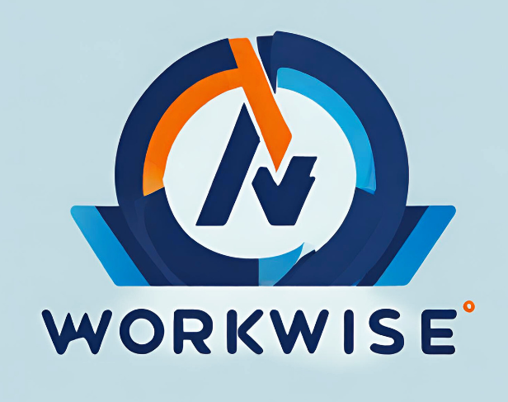

## 1.1 Background

The current landscape of tools lacks a dynamic and adaptive approach. Many existing applications rely on static methods for their operations, leading to suboptimal outcomes. This research aims to bridge this gap by introducing a GenAI-based adaptive system, ensuring that the system is more dynamic and intelligent.

Task management and goal setting is taken as one example to try and implement GenAI -based integration with the traditional way of building applications.

This research aims to bridge this gap by introducing a GenAi-based adaptive system, ensuring that task planning aligns with individual preferences and work styles. In our workplace, there exists a distinct requirement for a system that could facilitate goal setting and track’s goal progress effectively to improve overall productivity. By addressing the specific challenges encountered, this project directly aligns with the practical needs of the work environment.

## 1.2 Broad Area of Work

The "Adaptive Work Management Application for Elevated Productivity" is dedicated to resolving challenges encountered by working professionals in task prioritization and goal setting. Focused on leveraging GenAI, the project aims to introduce intelligent solutions for enhanced productivity in response to the evolving demands of the modern workplace. This research aligns with cutting-edge advancements in artificial intelligence and explores the intersection of:

* **Dynamic Task Prioritization:** Utilizing GenAI for adaptive and personalized task planning.
* **Smart Goal Setting:** Implementing intelligent goal-setting mechanisms based on SMART criteria.

The system will not only address immediate concerns but also contributes to the broader landscape of AI applications in work management. By harnessing GenAI's capabilities, the aim is to identify how well the integration of AI in our current application would be beneficial.

## 1.3 Literature References

The following are some references from the preliminary literature review.

[1] Bahrami, Z., Heidari, A., & Cranney, J. (2022). Applying SMART Goal Intervention Leads to Greater Goal Attainment, Need Satisfaction, and Positive Affect. International Journal of Mental Health Promotion, 28 September 2022. <https://doi.org/10.32604/ijmhp.2022.018954>

[2] Ullah, Z., Arif, I. M. Q., & Qaisar, R. (February 2020). Comparative Analysis of Productivity Apps on Time Management: A Survey-Based Study. Presented at the National Conference on Education (NCE-2020), Department of Education, National University of Modern Languages (NUML), H-9/4, Islamabad, Pakistan. [https://www.researchgate.net/publication/352546473_Comparative_Analysis_of_Prod uctivity_Apps_on_Time_Management_A_Survey_Based_Study](https://www.researchgate.net/publication/352546473_Comparative_Analysis_of_Prod%20uctivity_Apps_on_Time_Management_A_Survey_Based_Study)

[3] A. Nguyen-Duc, B. Cabrero-Daniel, A. Przybylek, C. Arora, D. Khanna, T. Herdag, U. Rafiq, J. Melegati, E. Guerra, K.-K. Kemell, M. Saari, Z. Zhang, H. Le, T. Quan, P. Abrahamsson, "Generative Artificial Intelligence for Software Engineering - A Research Agenda," in University of South Eastern Norway, BøI Telemark, Norway, 3800

<https://papers.ssrn.com/sol3/papers.cfm?abstract_id=4622517>

## 1.4 Objectives

The core objective of this research project encompasses designing and implementing WorkWise.

The specific goals include:

* **Adaptive Task Prioritization System:** Develop a dynamic system utilizing GenAI to prioritize tasks based on individual preferences and work styles.
* **Intelligent Goal Setting:** Implement a SMART goal-setting mechanism that leverages GenAI to guide users in defining Specific, Measurable, Achievable, Relevant, and Time-bound objectives.
* **Dashboard and Reporting:** Design an intuitive dashboard interface presenting task-related metrics, progress, and status updates.

## 1.5 Scope of Work

The scope of this dissertation includes the development of WorkWise.

The breakdown is as follows:

* **User Application Development:** Develop a user-friendly application for efficient task and goal planning.
* **Prompt Engineering with GenAI:** For the selected GenAI model, work on the prompts to get the required results in the application.
* **API Interface Development:** Creating an API interface for seamless interaction and execution of prompts within the application.
* **Database Integration:** Integrate a robust database for tracking tasks and generating dashboards and reports.

# CHAPTER 2: APPLICATION ARCHITECTURE

The core of WorkWise is the WorkWise Web Application which provides a user-friendly UI for the working professionals to work smart. This application, built with Angular, is accessible directly from web browsers.

The users can access the application using any device that includes support for web browser such as,

* Desktop Computers,
* Laptops,
* Tablets, etc.

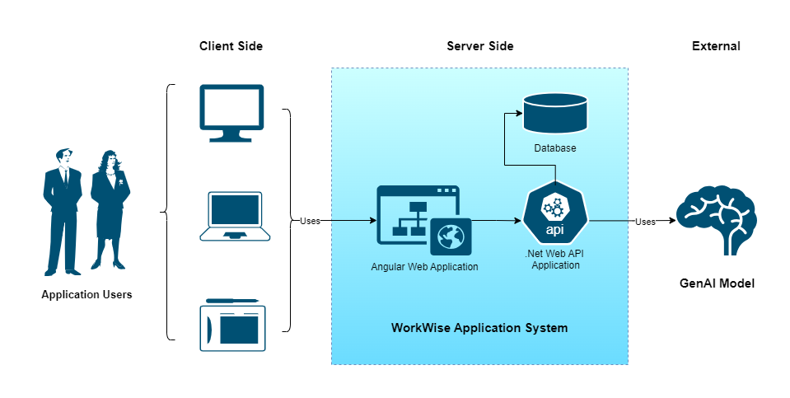*Figure 1: Architecture Diagram*

The WorkWise Web API Application is the engine behind the scenes. Created with .NET, it handles data tasks and connects to a PostgreSQL database for storing and retrieving user data securely.

For intelligent features, we leverage Gemini, a GenAI model from Google through the API interface. This allows the system to offer personalized recommendations and insights to users, enhancing productivity.

# CHAPTER 3: SYSTEM DESIGN DIAGRAMS

The following section presents the technical design diagrams (C4 Model) for WorkWise.

It includes,

* System Context Diagram
* Container Diagram
* Component Diagram

## 3.1 System Context Diagram

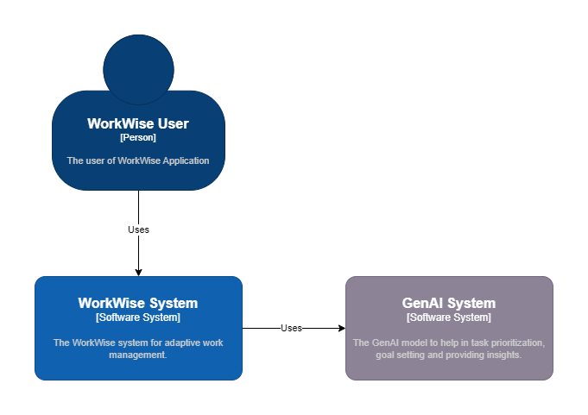

*Figure 2: WorkWise System Context Diagram*

The System Context Diagram shows the different entities within the ecosystem of the WorkWise application. It depicts three main components: the user interacting with the system, the WorkWise system itself, and the GenAI external system.

## 3.2 Container Diagram

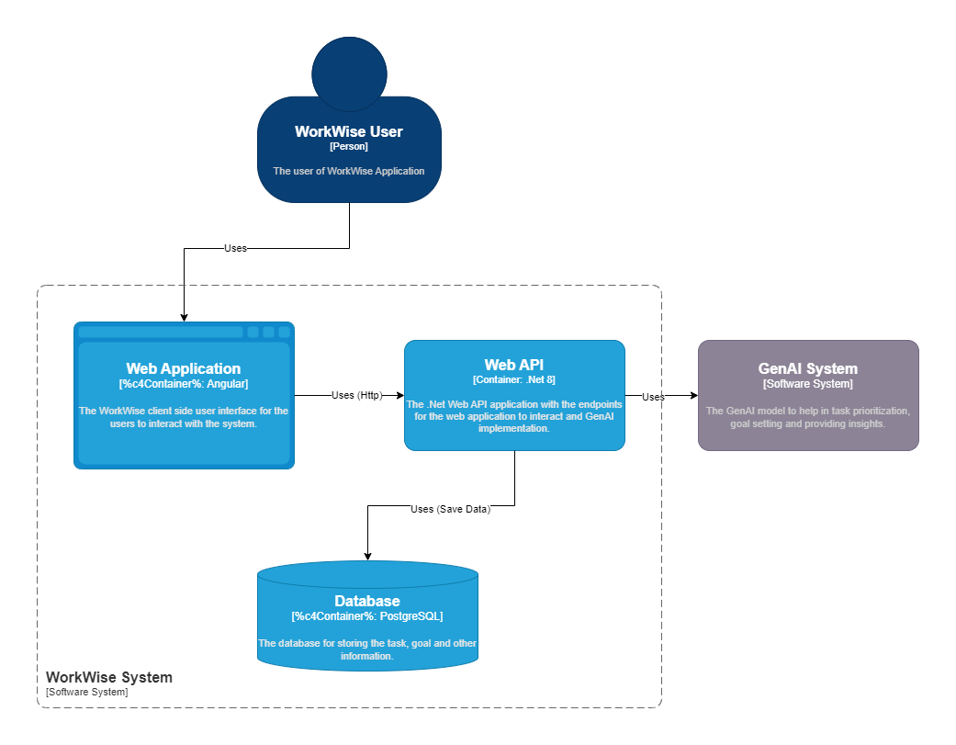*Figure 3: WorkWise Container Diagram*

The Container Diagram shows how the WorkWise system is structured.

It focuses on three main parts:

1. **WorkWise Web Application:** This is what users see and interact with. It's like the face of the system, made using Angular and accessed through web browsers.
2. **WorkWise API Application:** This is the brain behind the scenes. It's built with .NET and manages data tasks. It's the link between the front end and the database.
3. **Database:** This is where all the important information is stored. It's like a digital filing cabinet, keeping track of user data, tasks, and goals.

## 3.3 Component Diagram

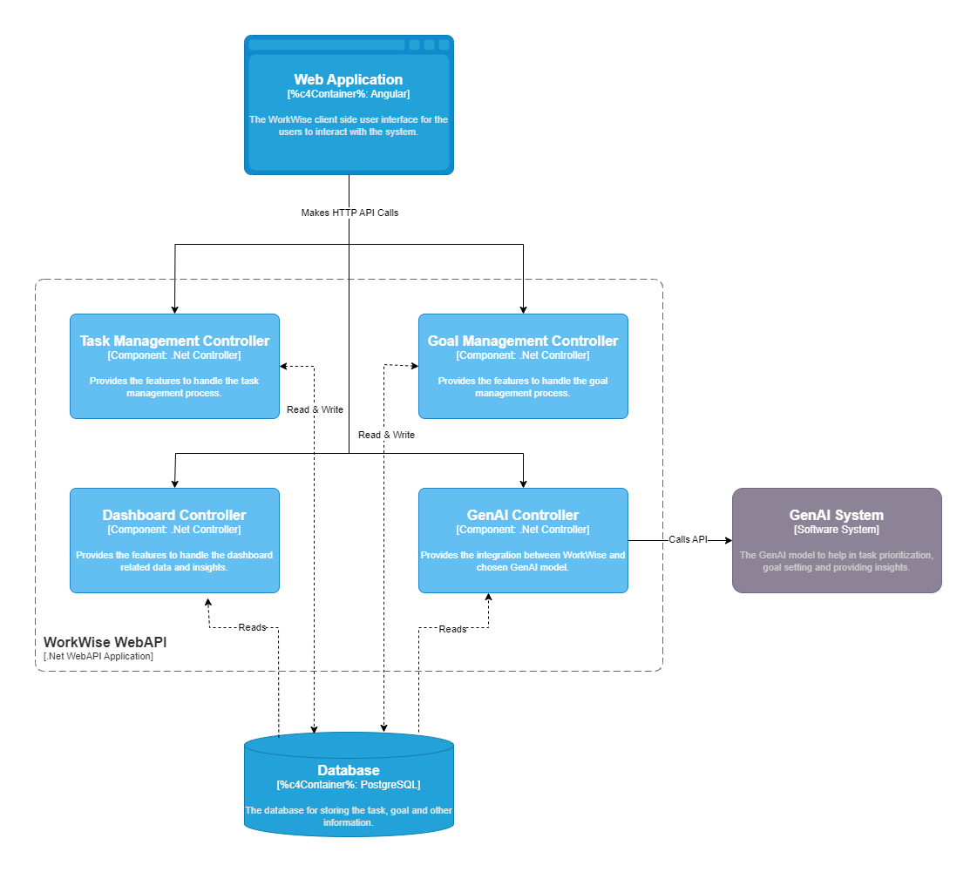*Figure 4: WorkWise Component Diagram*

The Component Diagram elaborates on the containers within the WorkWise API application. The four main components: The Task Management Controller, Goal Management Controller, Dashboard Controller, and GenAI Controller. The diagram also shows how the different components interact with each other.

# CHAPTER 4: GENAI MODEL

The GenAI model used in WorkWise is Gemini, provided by Google. This advanced artificial intelligence model is chosen for its growing popularity and accessibility. It offers a free developer version currently, making it an ideal choice for testing and integration into the application.

Gemini is seamlessly integrated into WorkWise through the Gemini API endpoint. This integration allows for efficient communication between the application and the GenAI model.

## 4.1 Prompt Engineering

WorkWise utilizes prompts to interact with the Gemini model and obtain the desired outcomes. Prompts are carefully crafted inputs provided to the model to get the specific responses tailored to the user's needs and queries.

The application dynamically generates prompts based on the user inputs and current context. This adaptive approach ensures that the prompts align with the user's requirements and facilitate efficient task prioritization, goal setting, and productivity enhancement.

## 4.2 Response Handling

Upon receiving responses from the Gemini model, WorkWise processes and presents them to the user in a clear and actionable format. The prompts are written in a manner to return the responses in an expected format preferably Json. The application interprets and analyzes the model's outputs to provide meaningful insights and recommendations to the user.

*Figure 5: Gemini Integration*

The above diagram summarizes the Gemini integration with WorkWise through the API interface.

## 4.3 Example Prompt

The prompt is constructed based on the inputs from the user and then sent to the GenAI model to get the result.

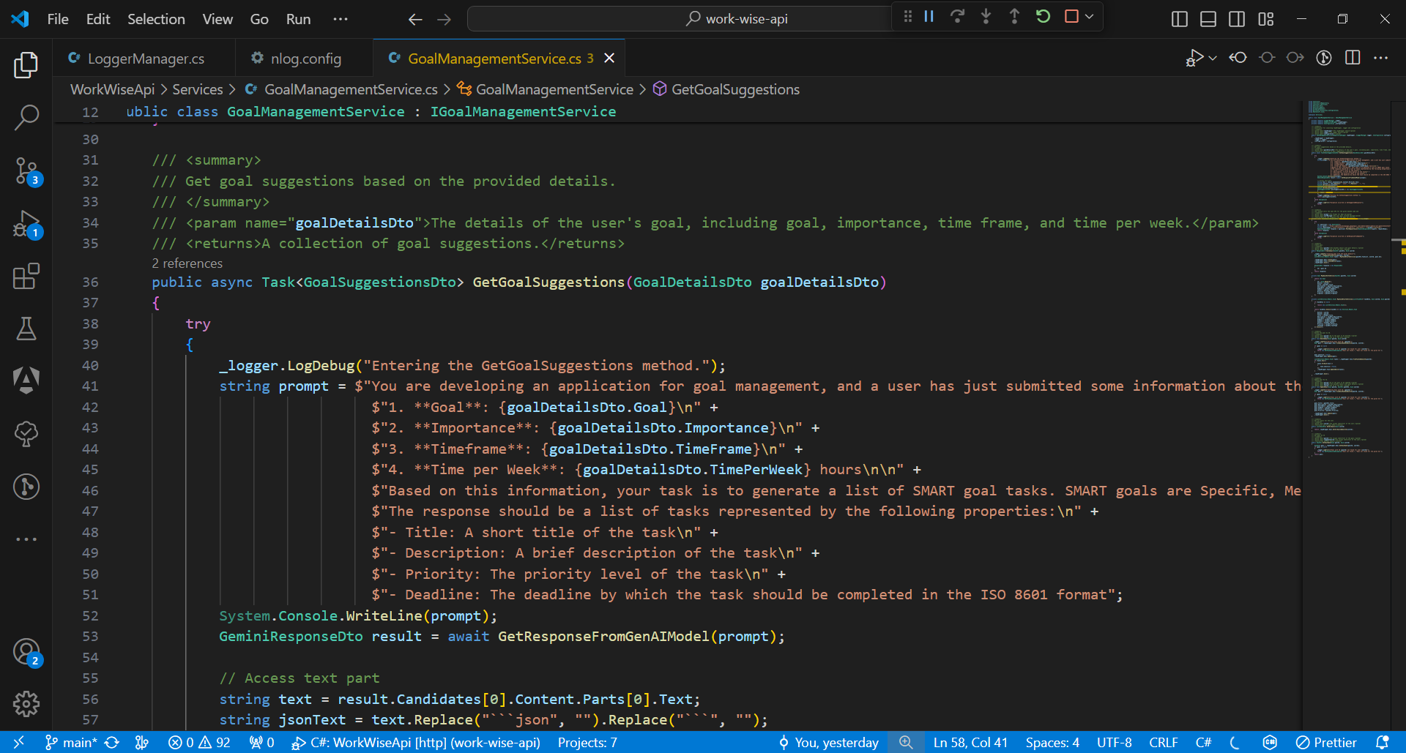

*Figure 6: Goal Suggestions Prompt*

## 4.4 API Integration

Below is the code snippet for making the API call to the Gemini model.

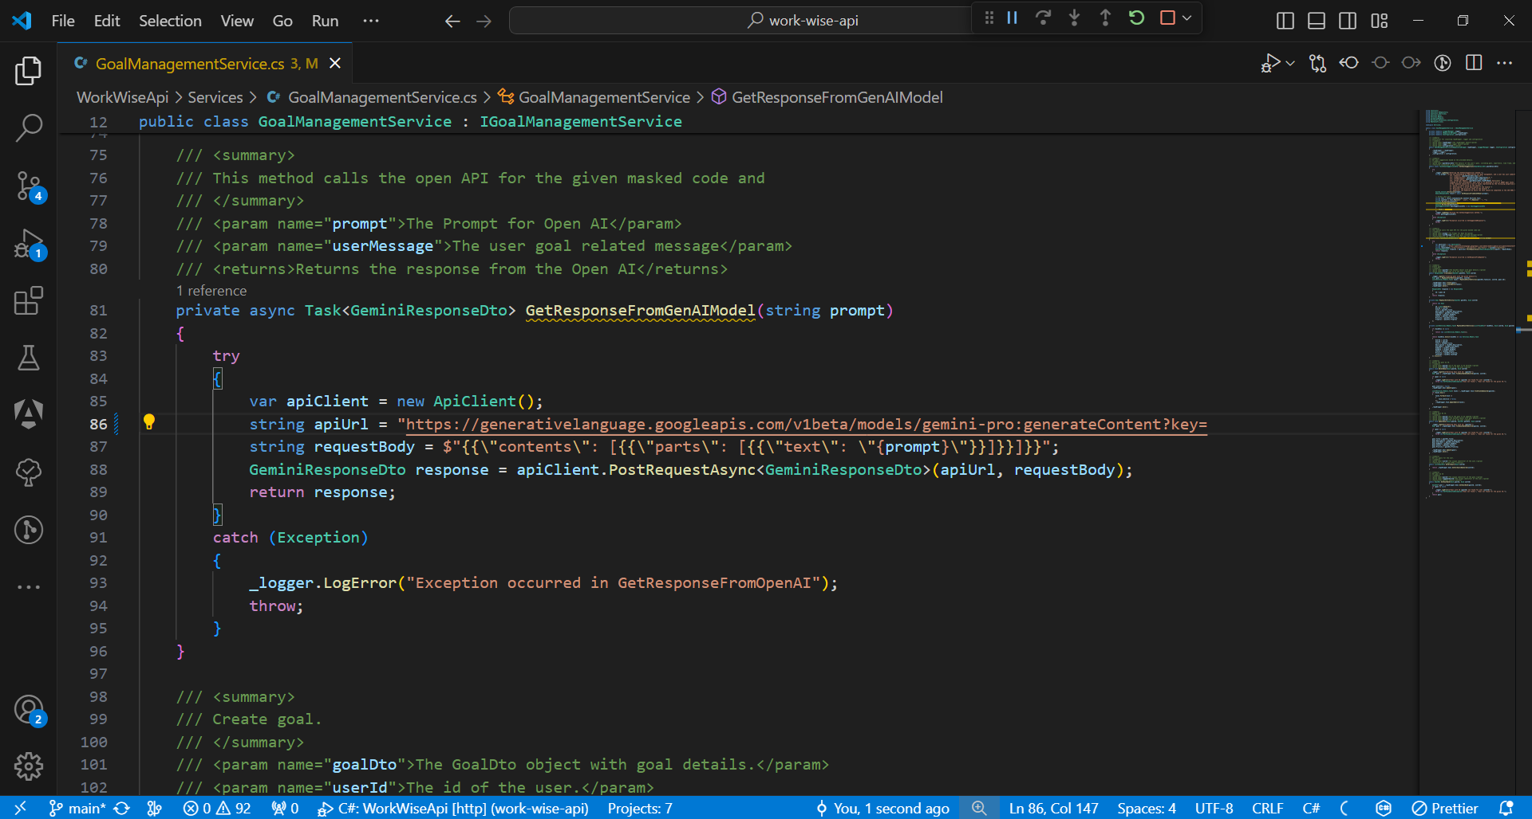

*Figure 7: Gemini API Integration Code*

# CHAPTER 5: TECHNICAL SPECIFICATIONS

## 5.1 Frontend Application

Framework : Angular 17

Language : TypeScript

Package Manager : NPM

Styling : SCSS

UI Components : Angular Material

Build Tools : Angular CLI

Code Quality : ESLint, Prettier

IDE : Visual Studio Code (VSCode)

## 5.2 Backend Web API Application

Framework : .NET 8

Language : C# (C Sharp)

IDE : Visual Studio

Dependency Management : NuGet

Database Integration : Entity Framework Core

Logging : NLog

## 5.3 Database Management System

Database : PostgreSQL

Language : SQL (Structured Query Language)

DB Administration Tool : pgAdmin

DB Connection : Npgsql (for .NET applications)

## 5.4 GenAI Model

Model : Gemini

Provider : Google

Integration : Gemini API

Version : Gemini 1.5 Pro

## 5.5 Tools and Installations

*Table 1: Tool Category and Name*

|  |  |
| --- | --- |
| Category | Tool/Installation Name |
| Frontend Development | Node.js |
|  | Angular CLI |
| Backend Development | .NET 8 SDK |
| Database Management System | PostgreSQL, PgAdmin |
| Integrated Development Environments | Visual Studio Code (VSCode) |
|  | Visual Studio |

# CHAPTER 6: DESIGN CONSIDERATIONS

## User-Centric Design

The priority is given to create an intuitive and easy-to-use interface. It is ensured to have seamless navigation for task and goal planning.

A simple side navigation is provided for the users to navigate and on-screen messages are provided to guide the users.

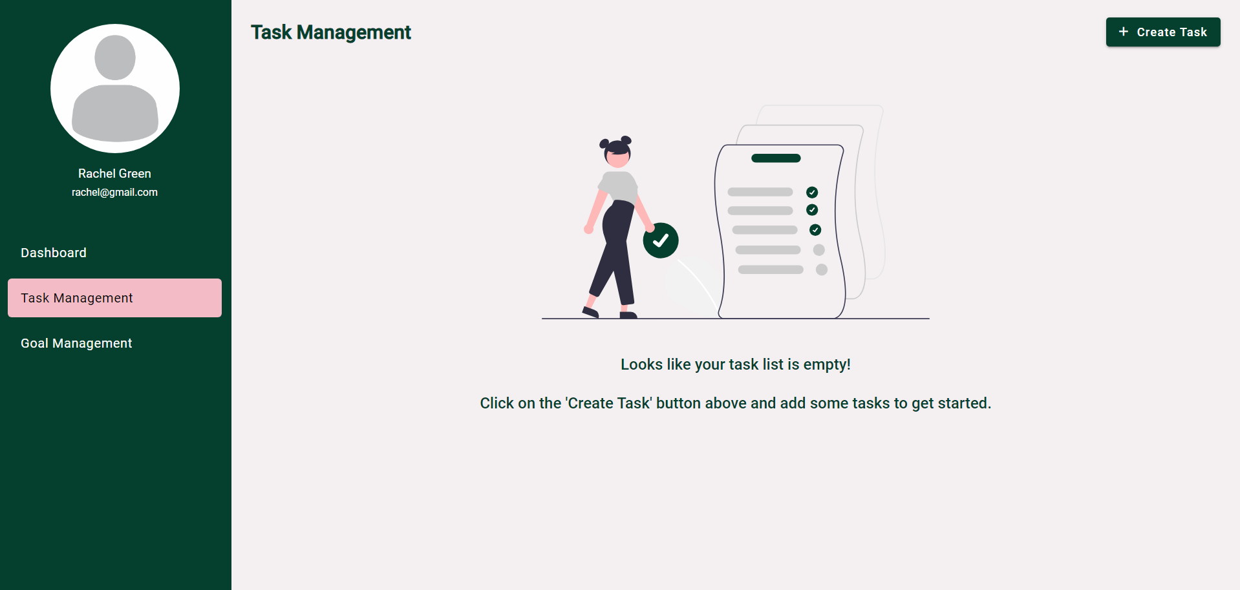

*Figure 6: Empty task management screen with an intuitive message.*

## 6.2 Security

Authentication and authorization mechanisms are implemented to control access to the application. A JWT token-based authorization is implemented for all user specific endpoints to ensure secure communication between clients and the server.

The Bearer JWT token for the logged in used is passed in the header for all the API end points after login is done to identify the user.

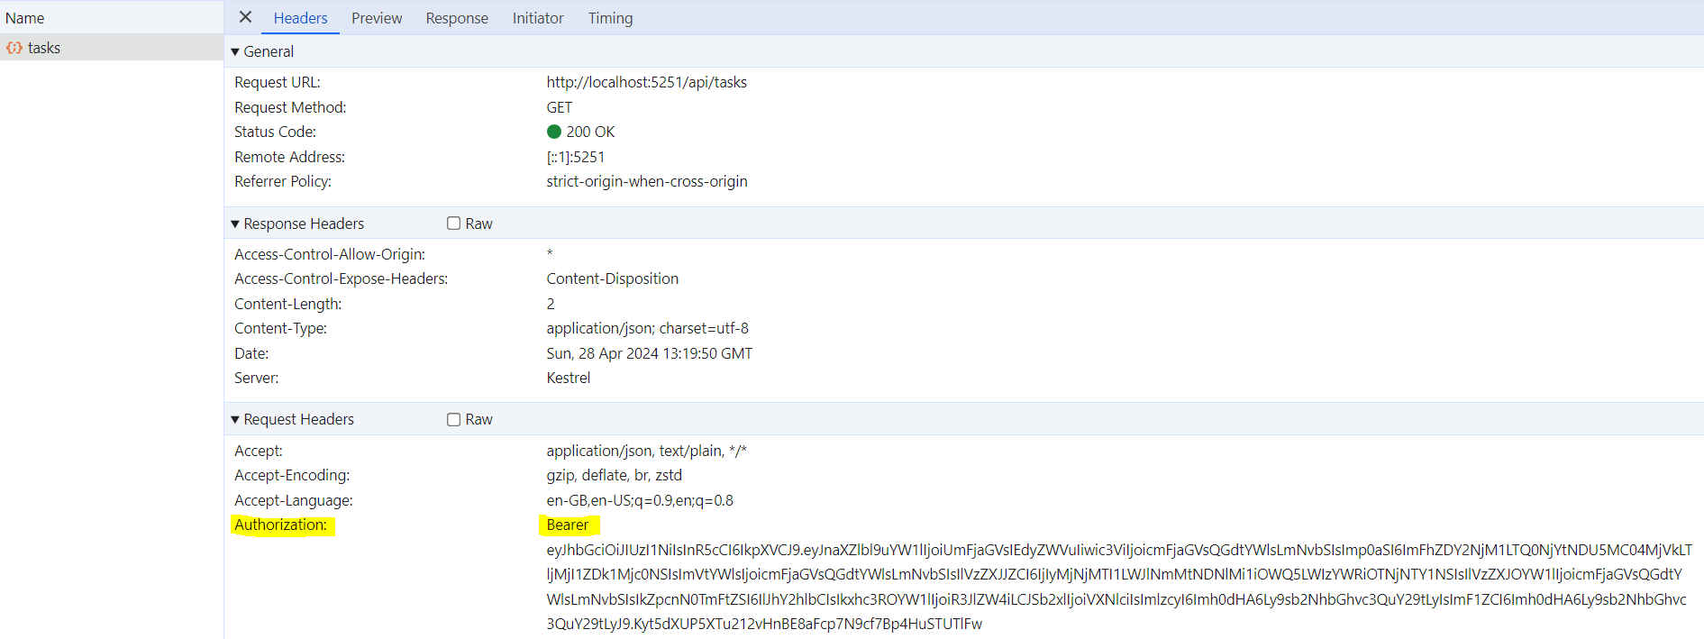

*Figure 7: JWT Bearer token being passed in Authorization header.*

The JWT token will contain the user information using which the identity will be proved. The token will contain basic information of the user and other application specific data for the user.

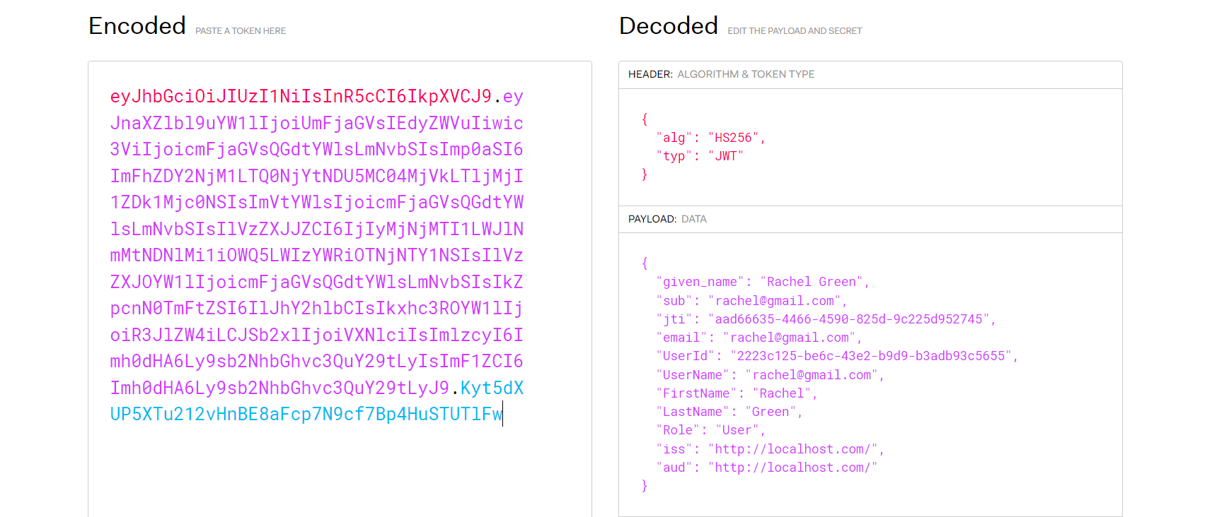

*Figure 8: Example for the Data in the JWT token.*

To protect user credentials from unauthorized access and potential breaches, the passwords are hashed and stored.

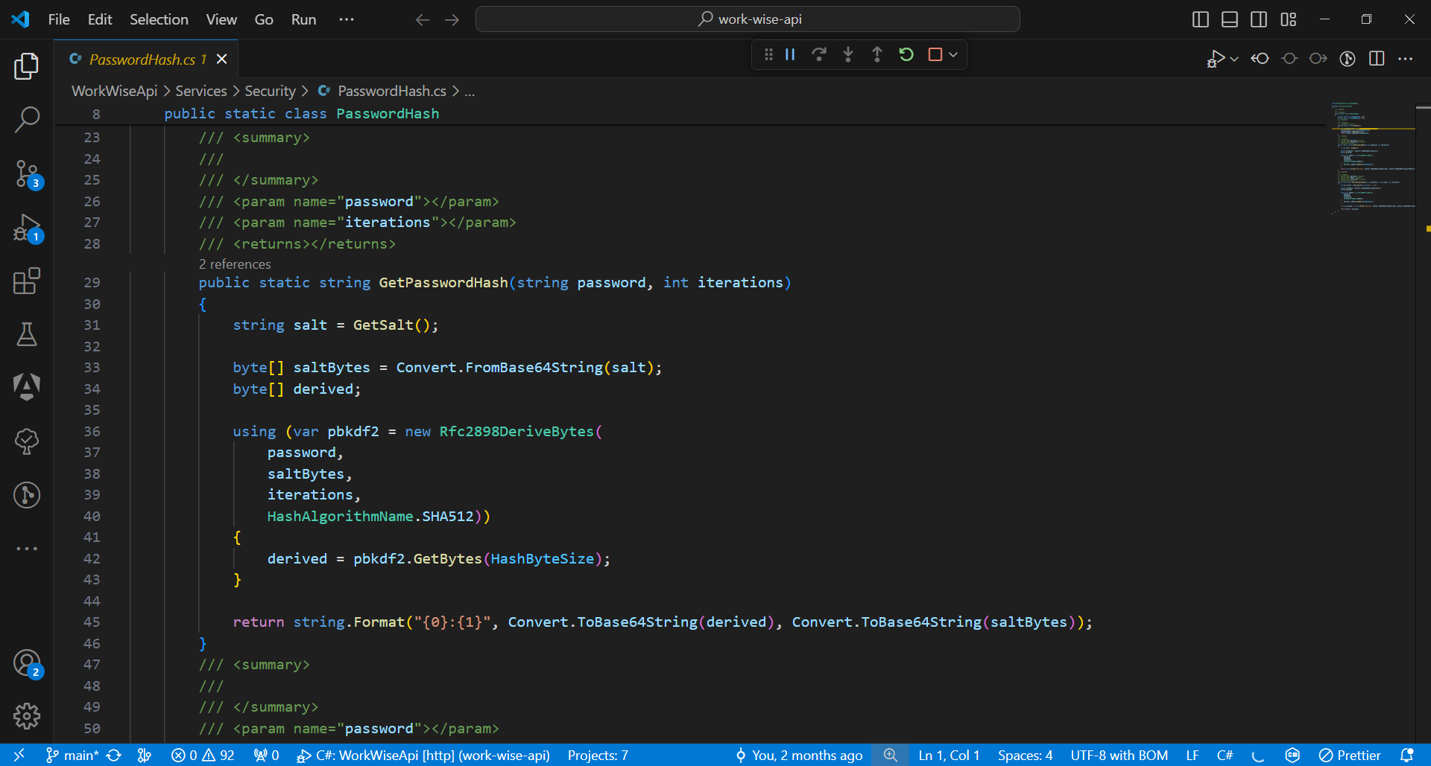*Figure 9: Method used for hashing passwords.*

## 6.3 Maintainability

* The coding standards and best practices are followed to ensure code consistency, readability, and maintainability.
* A comprehensive logging mechanism is implemented in the backend application to track system activities, errors, and user interactions, aiding in troubleshooting and debugging.

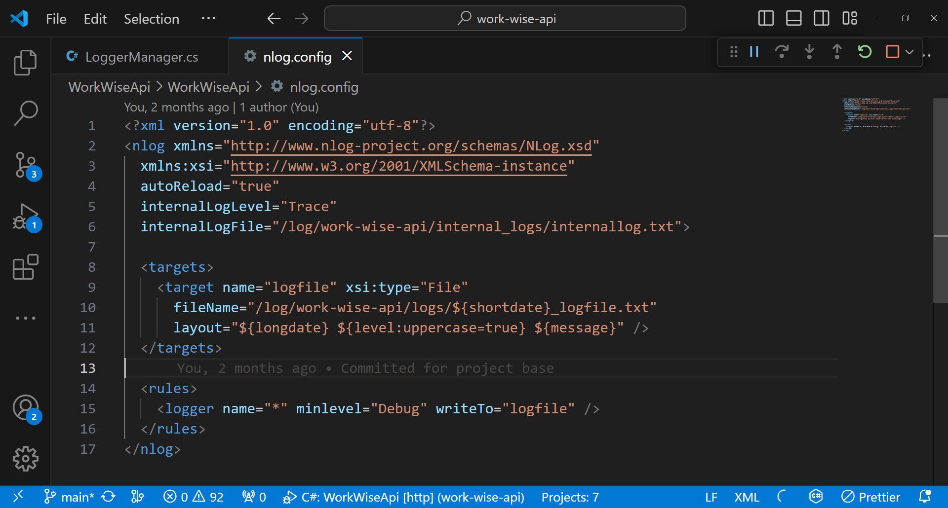*Figure 10: .Net NLog Configuration.*

# CHAPTER 7: MODULES

## 7.1 Goal Management

In the Goal Management module, users can create and track goals. They can also easily update and delete the goals if required.

Each goal adheres to the SMART criterial and includes details such as the name, description, priority, start date, due date, status etc. Additionally, each goal consists of a set of tasks making the goals measurable and track the progress. The Gemini model assists users in the goal creation process.

### 7.1.1 Create Goal

The goal creation process includes the below steps:

1. Navigate to the “Goal Management” tab and click on “Create Goal”.

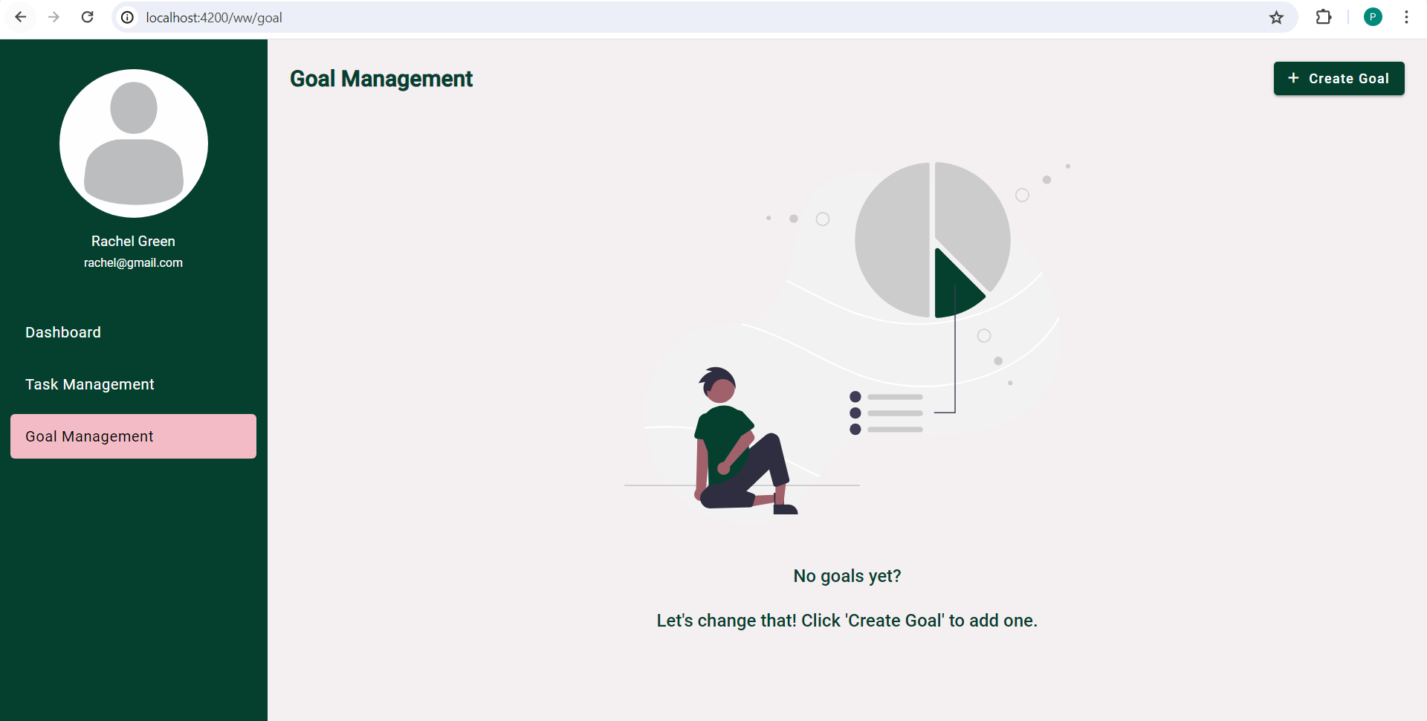

*Figure 11: Empty Goal Management Tab.*

1. Fill the goal details form and click next.

The goal details include some questions related to the goal and the based on the input the tasks will be suggested by GenAI.

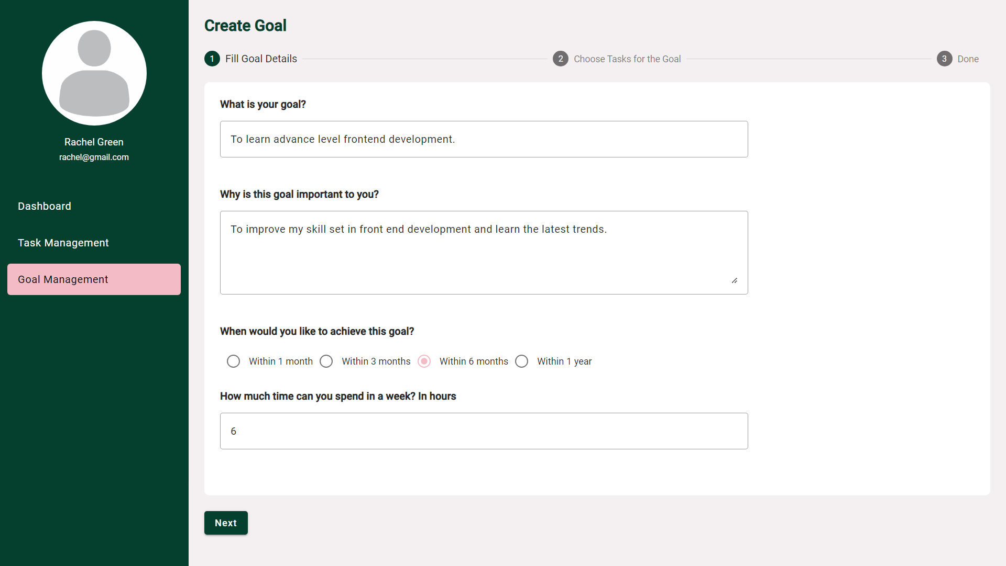

*Figure 12: Create Goal – Goal Details Form.*

1. The tasks will be generated with the help of GenAI and pre filled. The user can add more tasks and refine them further. Then click on Next.

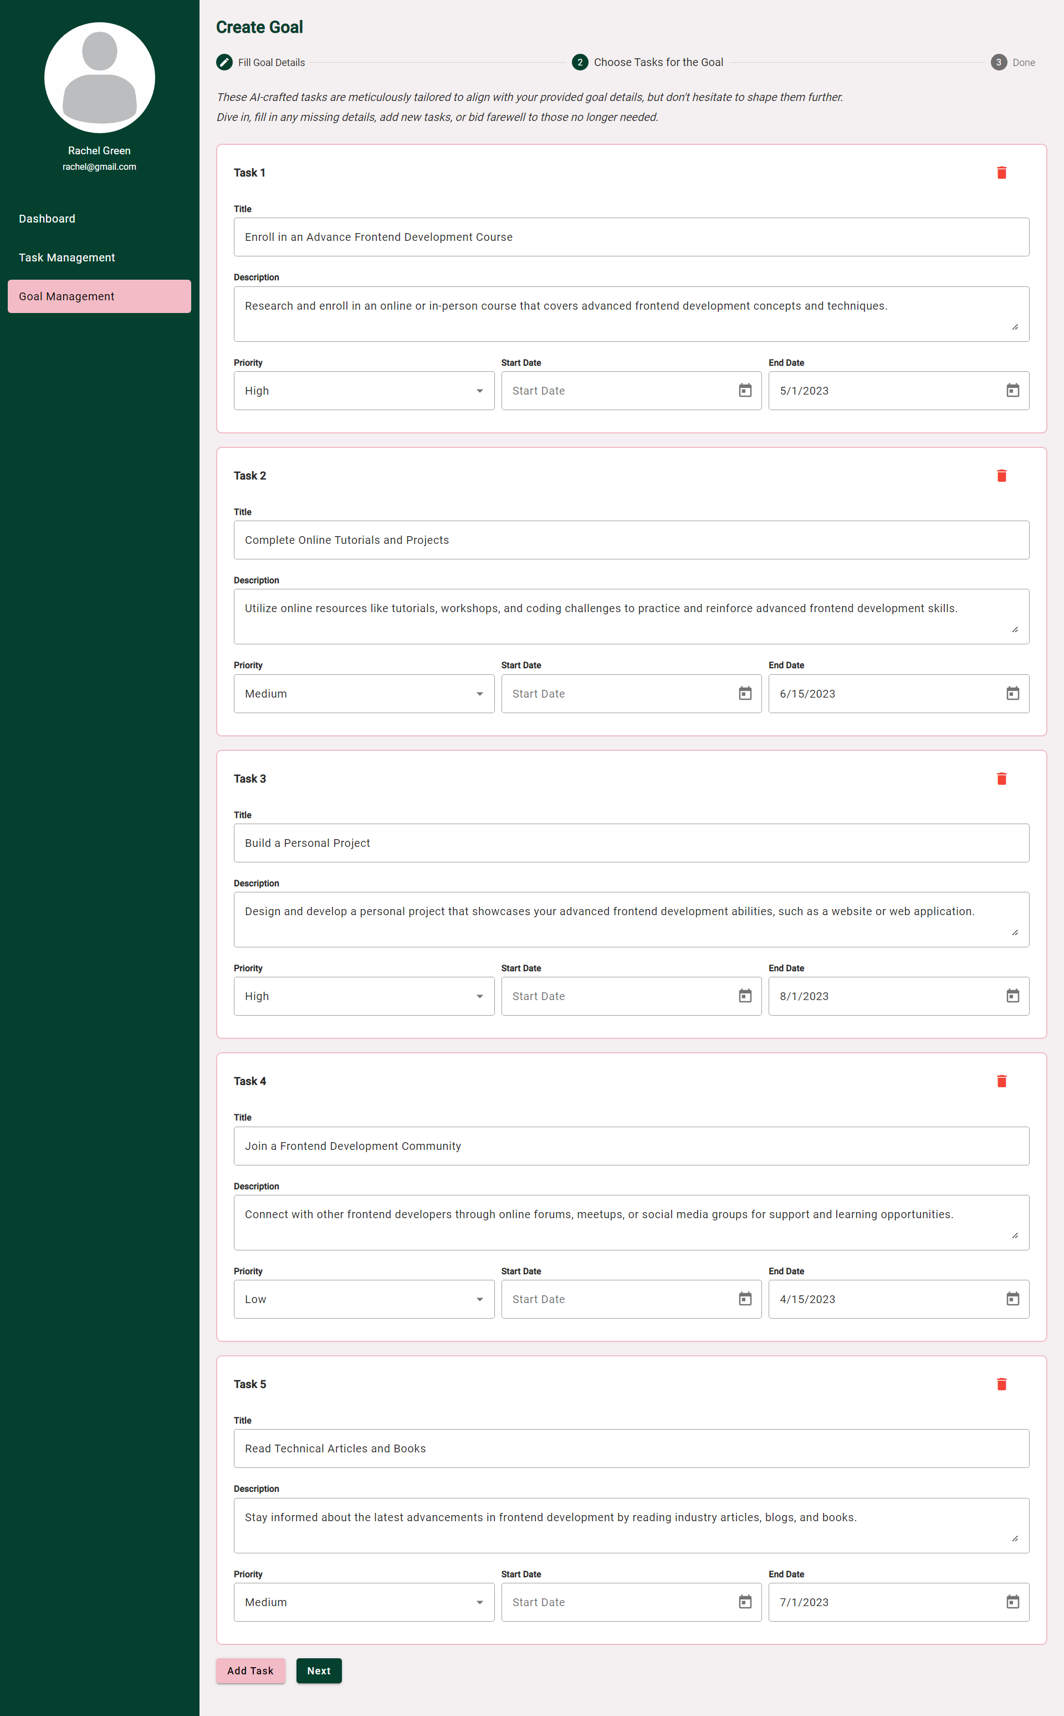 *Figure 13: Create Goal – Task Details Form.*

1. The last step is the confirmation on the goal and the task details. Check the details and click on “Create Goal”.

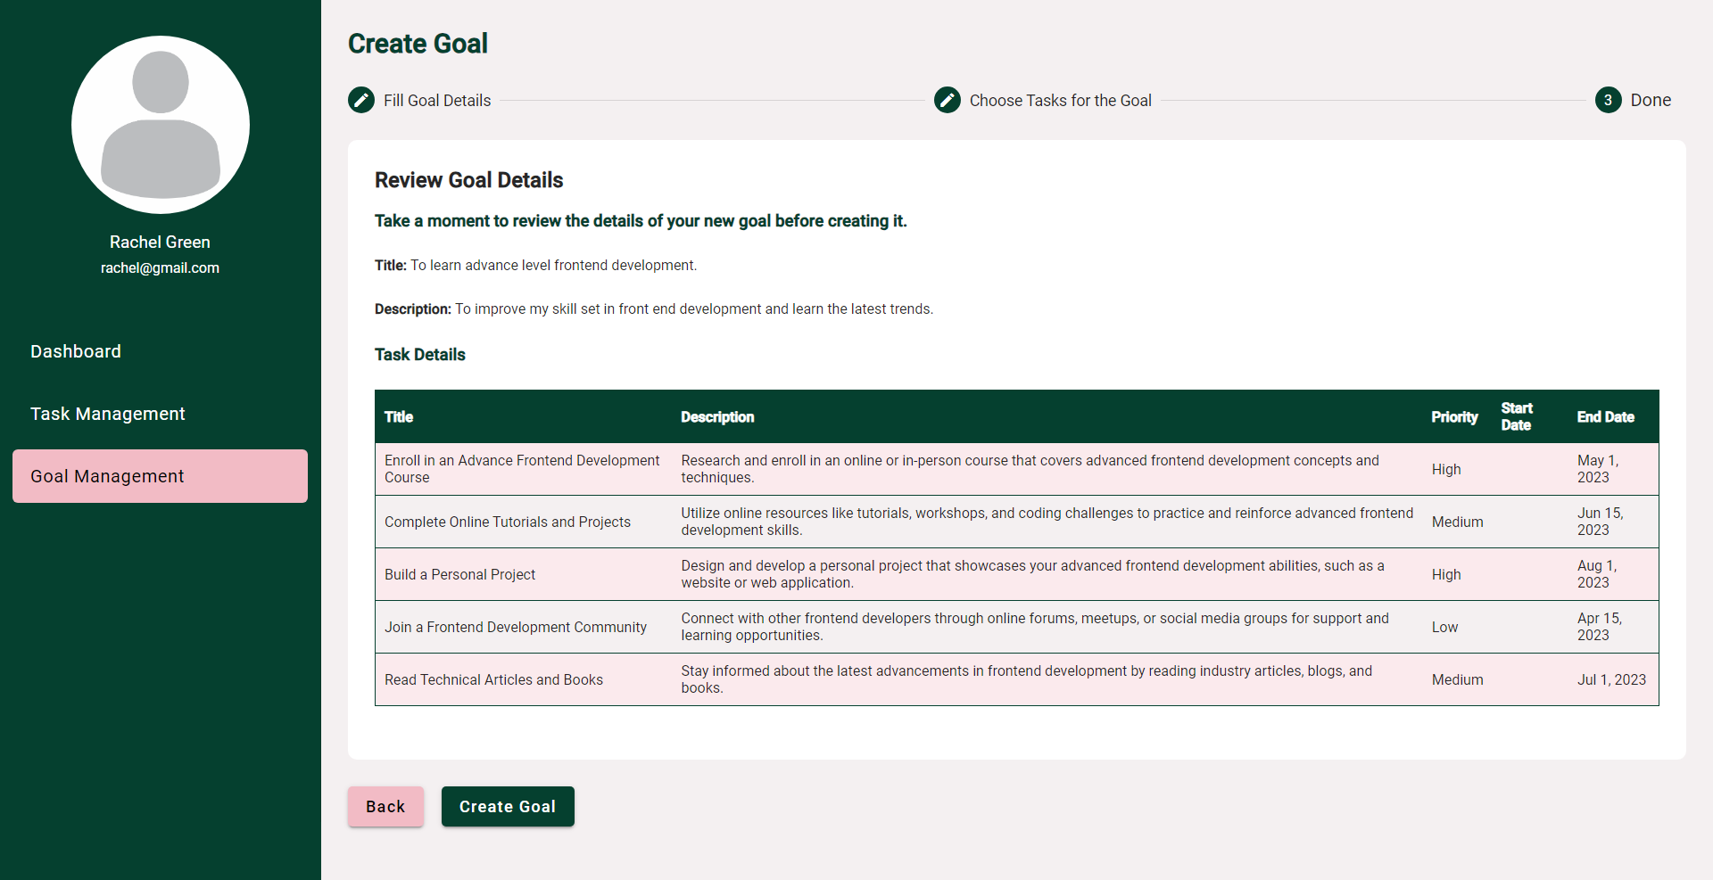

*Figure 14: Create Goal – Goal Confirmation.*

1. The goal will be created and added to the goal management list.

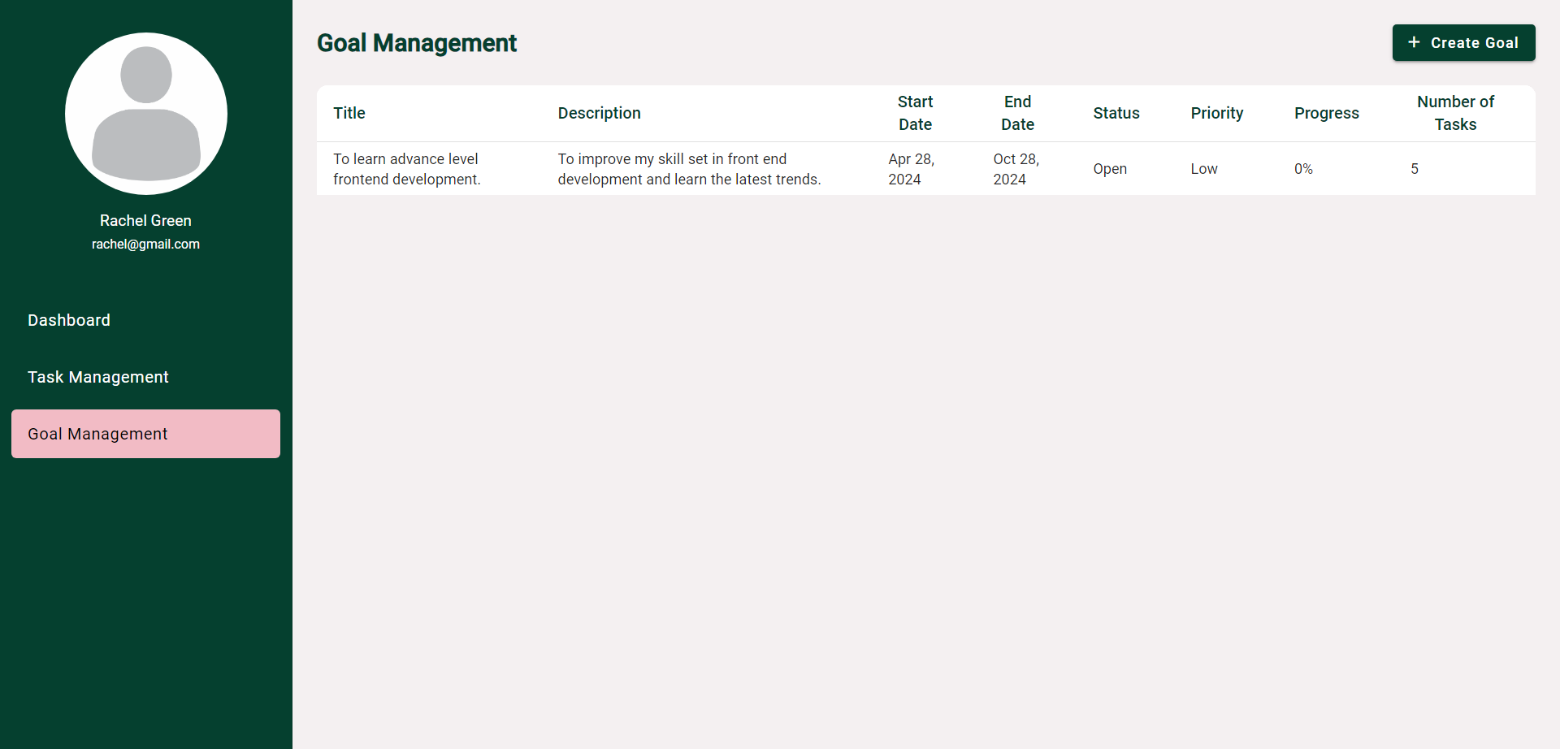

*Figure 15: Create Goal – Goa lCreated.*

### 7.1.2 Update Goal

As we make progress in the goal, we can update the goal and the task details.

The steps to update are:

1. Click on the goal that needs to be updated.

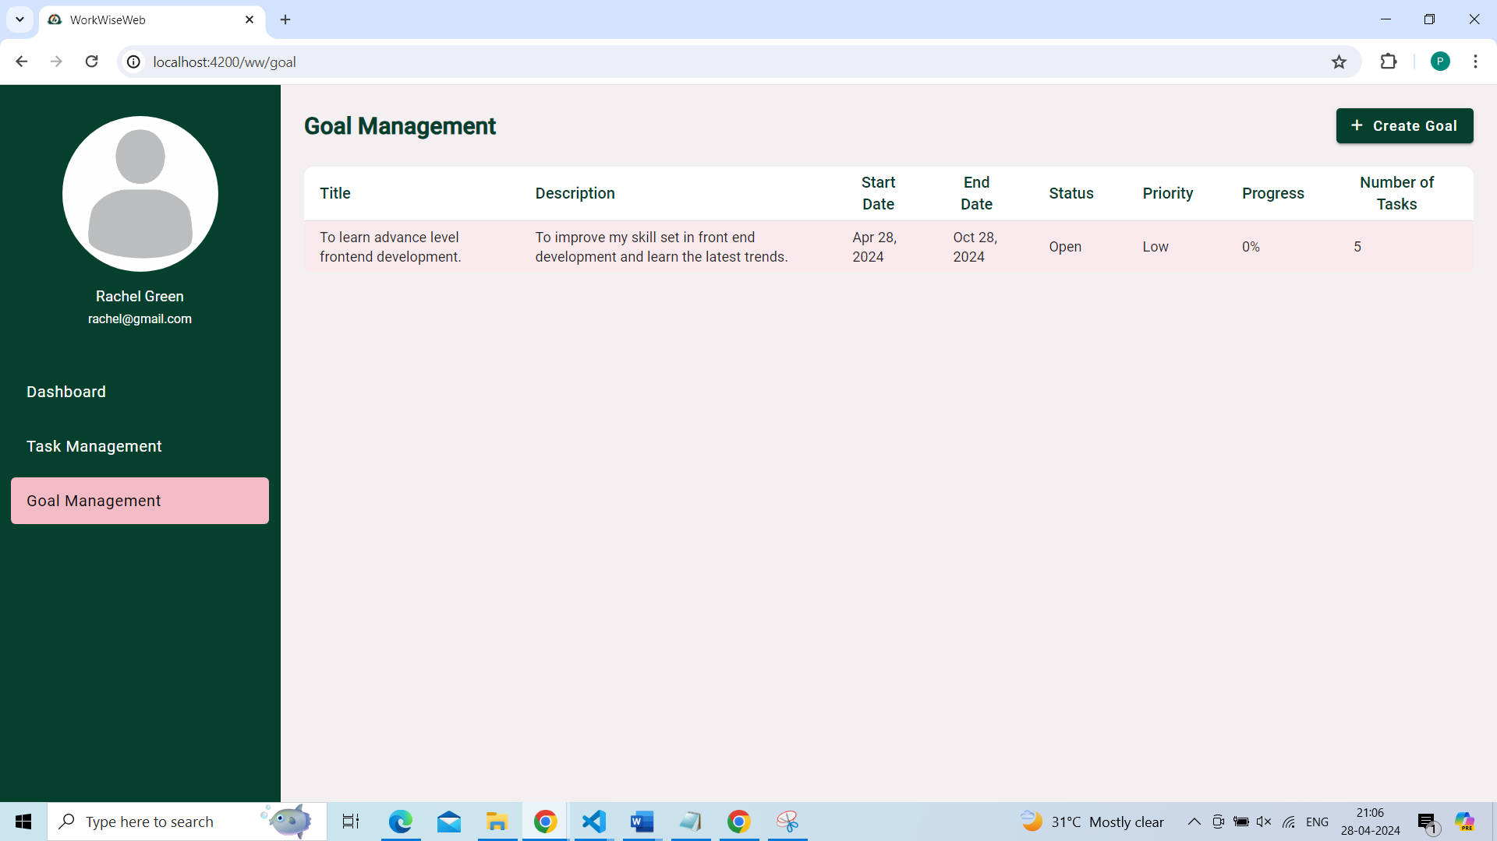

*Figure 16: Update Goal – Goal List Selection.*

1. The goal details page would open. Click “Update Goal”.

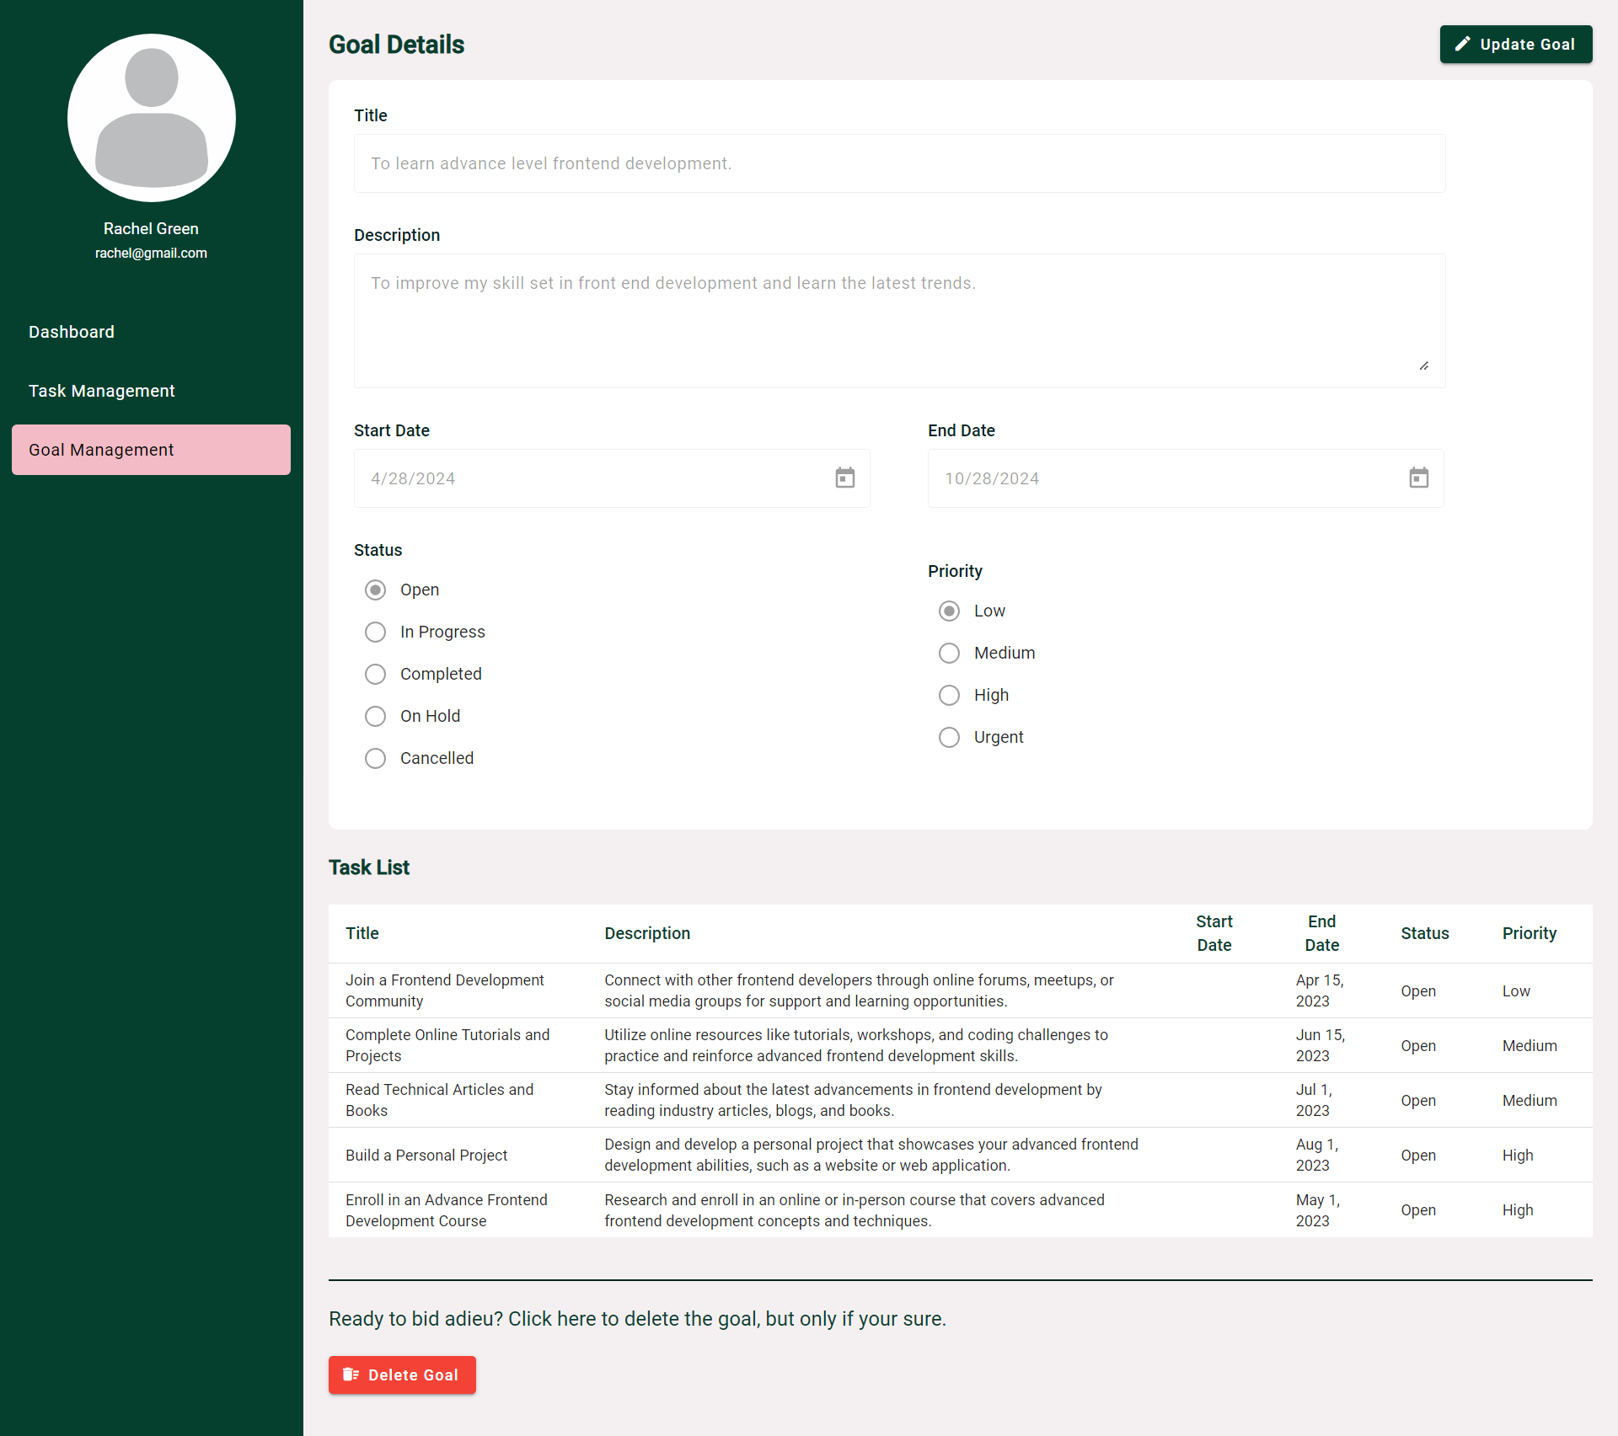

*Figure 17: Goal Details Page.*

1. The goal will now be editable. The goal and the task details can be updated and saved.

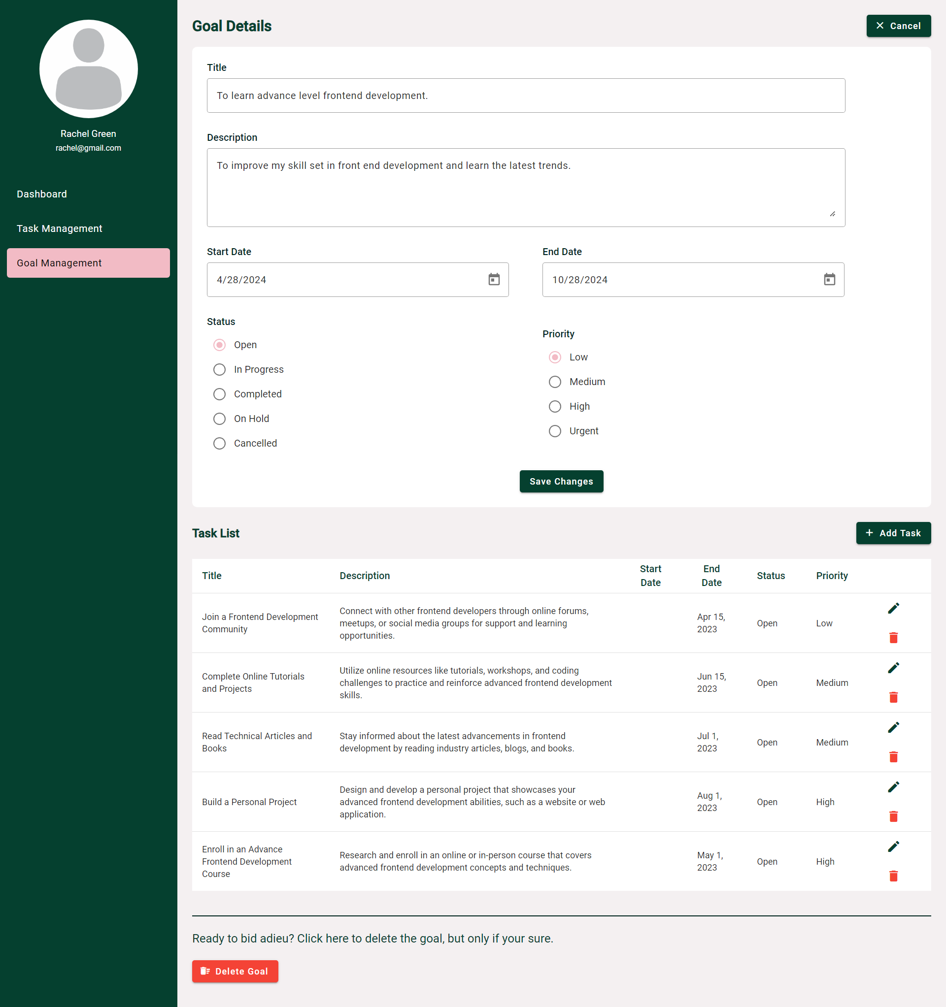

*Figure 18: Editable Goal Details Page.*

### 7.1.3 Delete Goal

The “Delete Goal” button in the bottom can be used to delete a goal and all the other related tasks within it.

A confirmation popup would open upon clicking the delete button and the goal will be removed after confirmation.

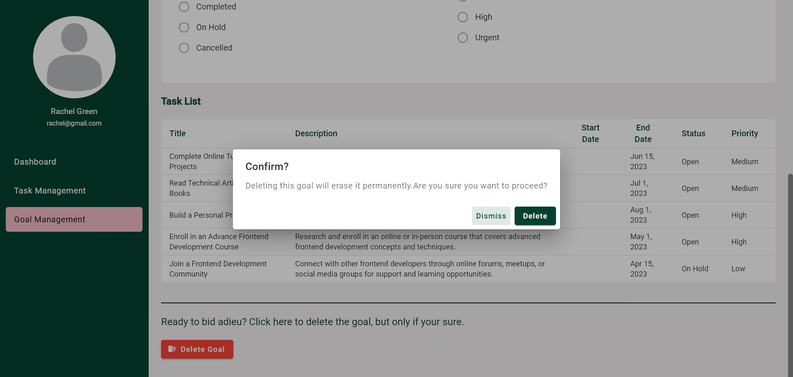

*Figure 19: Delete Goal Confirmation Popup.*

## 7.2 Task Management

The Task Management module lets users perform various actions like creating, updating, deleting, and viewing individual tasks like maintaining a to do list.

*Figure 20: Task Management Operations*

Each task includes details such as Task Name, Task Description, Priority, Start Date, Due Date, Status, etc.

### 7.2.1 Create Task

The task creation process is simple and has the below steps.

1. Open Task Management tab.

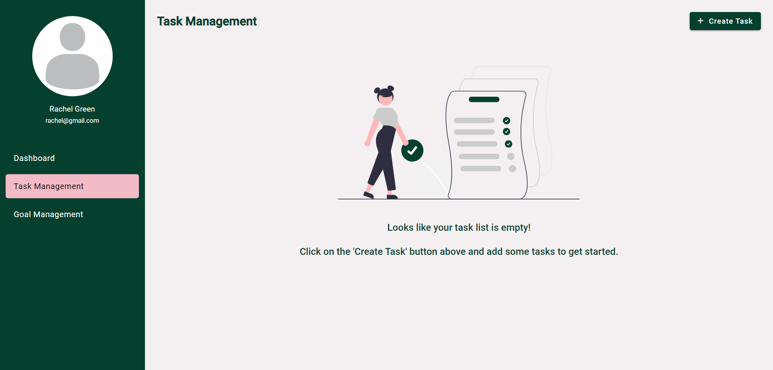

*Figure 21: Task Management Page.*

1. Click on “Create Task”. A form will open with the task details.

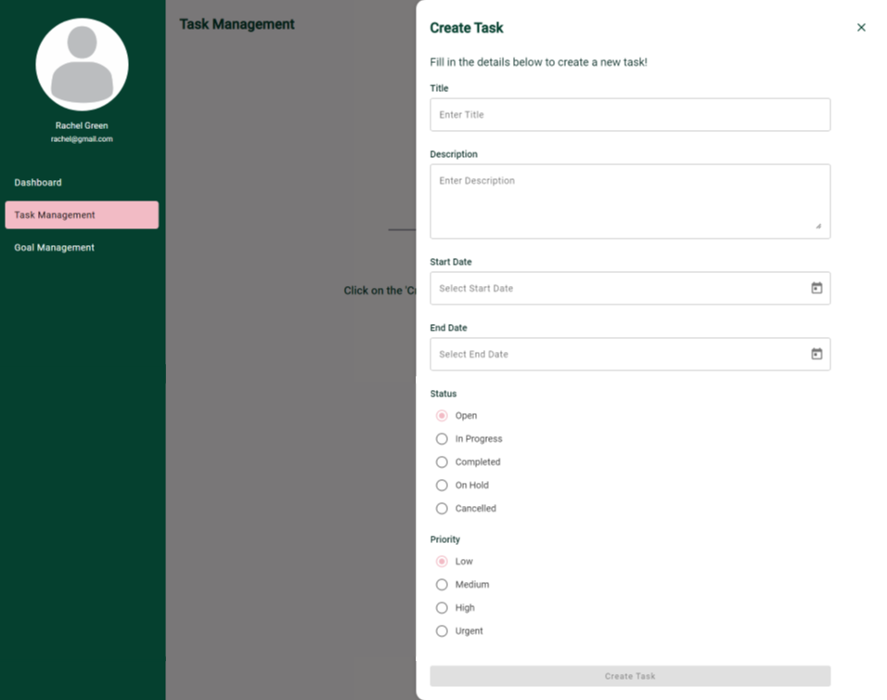

*Figure 22: Empty Create New Task Form.*

1. Fill up the form and click on “Create Task”.

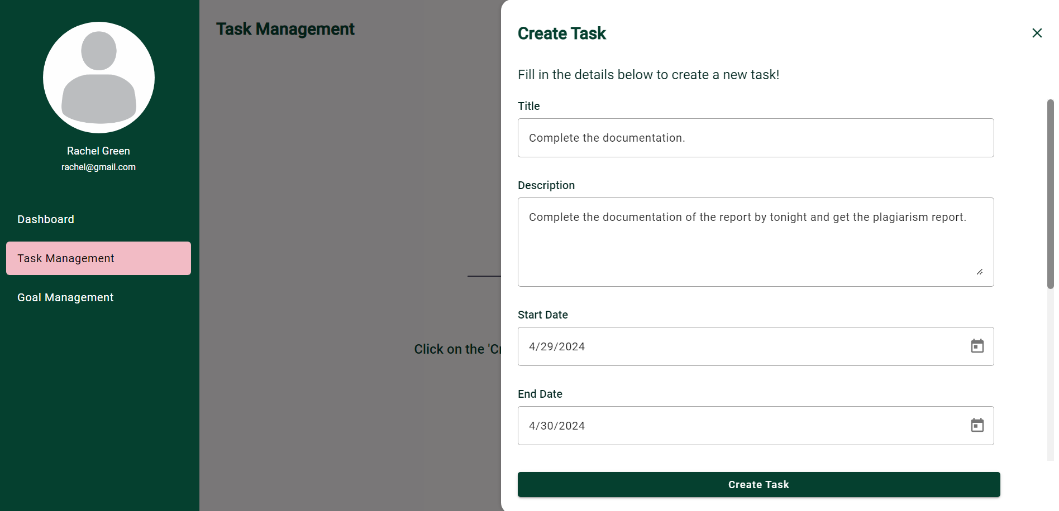

*Figure 23: Create New Task Form Filled.*

1. The task will be added and can be viewed in the task management list.

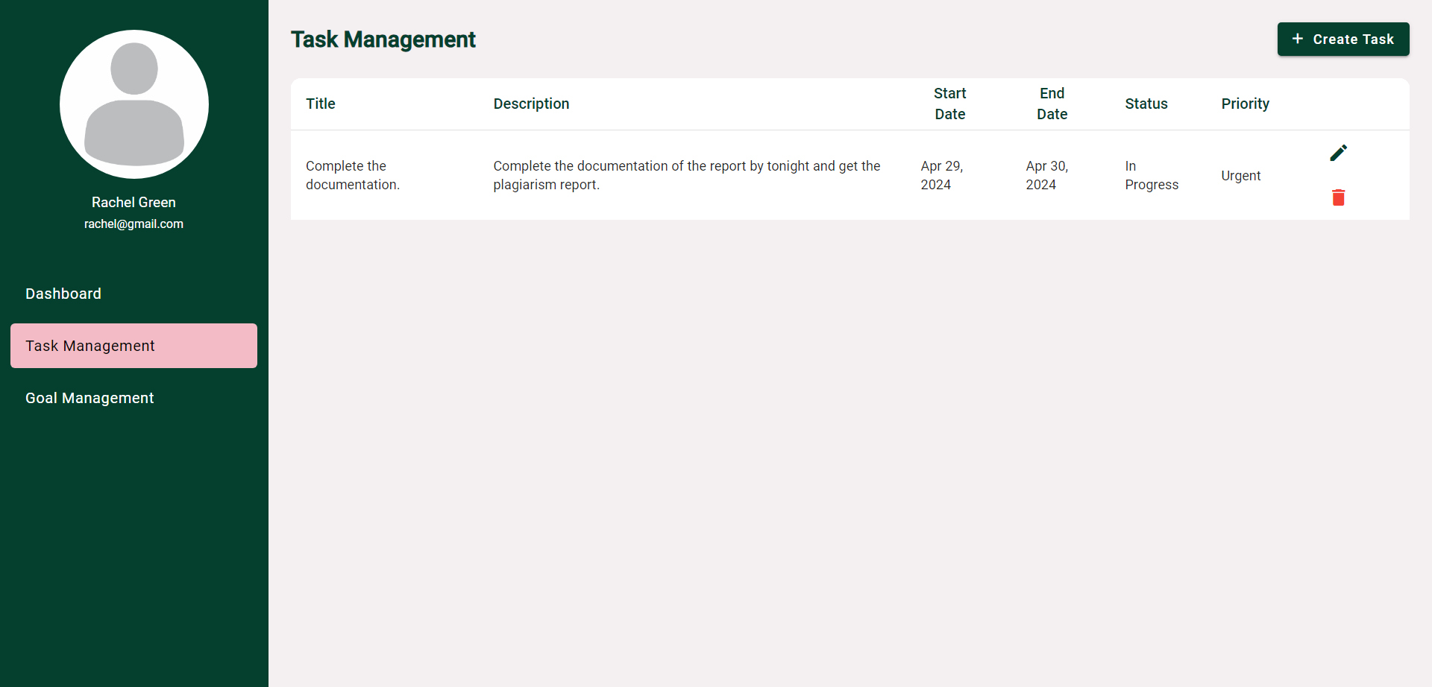

*Figure 24: New task added the list.*

### 7.2.2 Update Task

A task created can be updated by clicking on the “Edit pencil icon” which will open the same create task popup with the values prefilled.

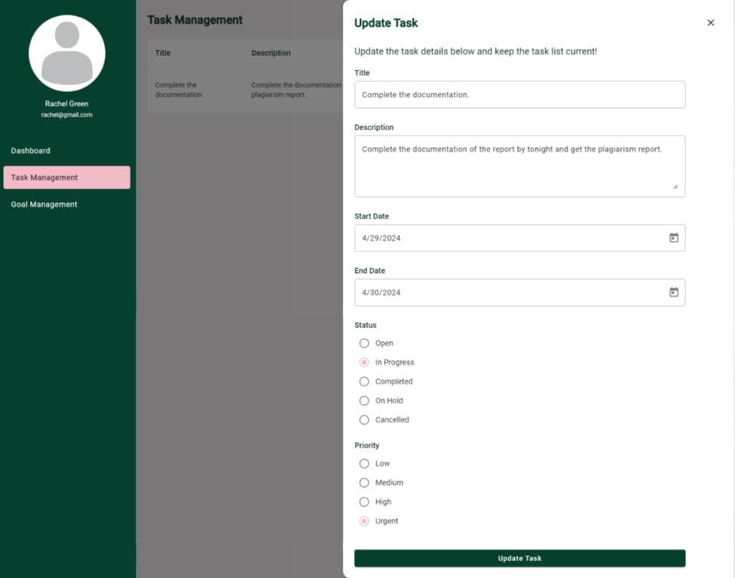*Figure 25: Update Task Form.*

### 7.2.3 Delete Task

A task created can be deleting by clicking on the “Delete icon” which will open a confirmation popup. On clicking “Delete” button, the task will be removed.

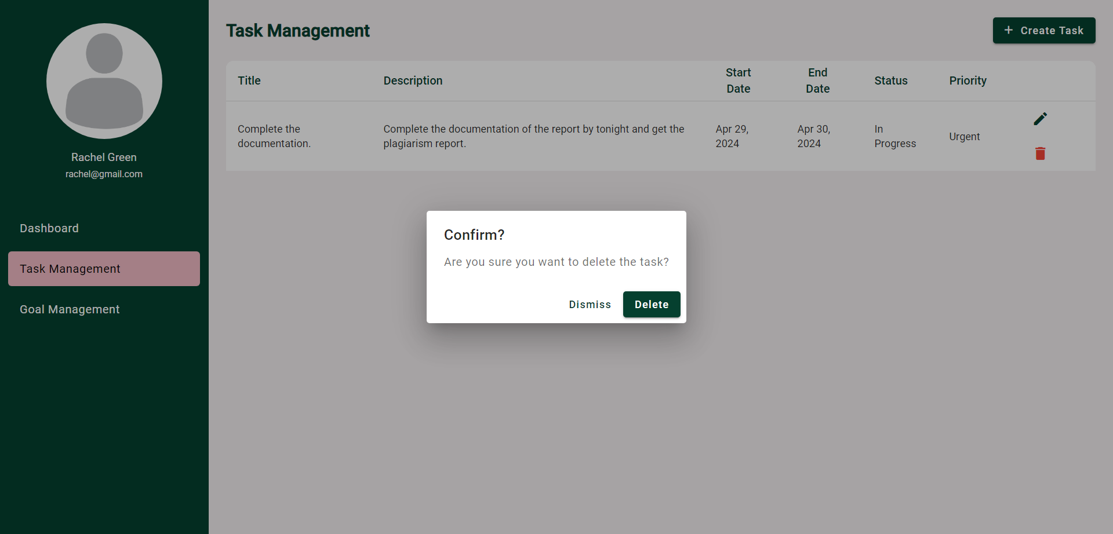

*Figure 26: Delete Task Confirmation Popup.*

### 7.2.4 Task prioritization

To assist users in prioritizing the tasks, an additional feature has been implemented where they can seek guidance from the GenAI model to prioritize available tasks through a button click.

## 7.3 Dashboard Insights

The Dashboard Insights module helps users keep track of their tasks and goals in one place, making it easy to see how they're doing.

The dashboard involves charts, graphs, lists etc. to display the task and goal progress in an easy to interpret manner.

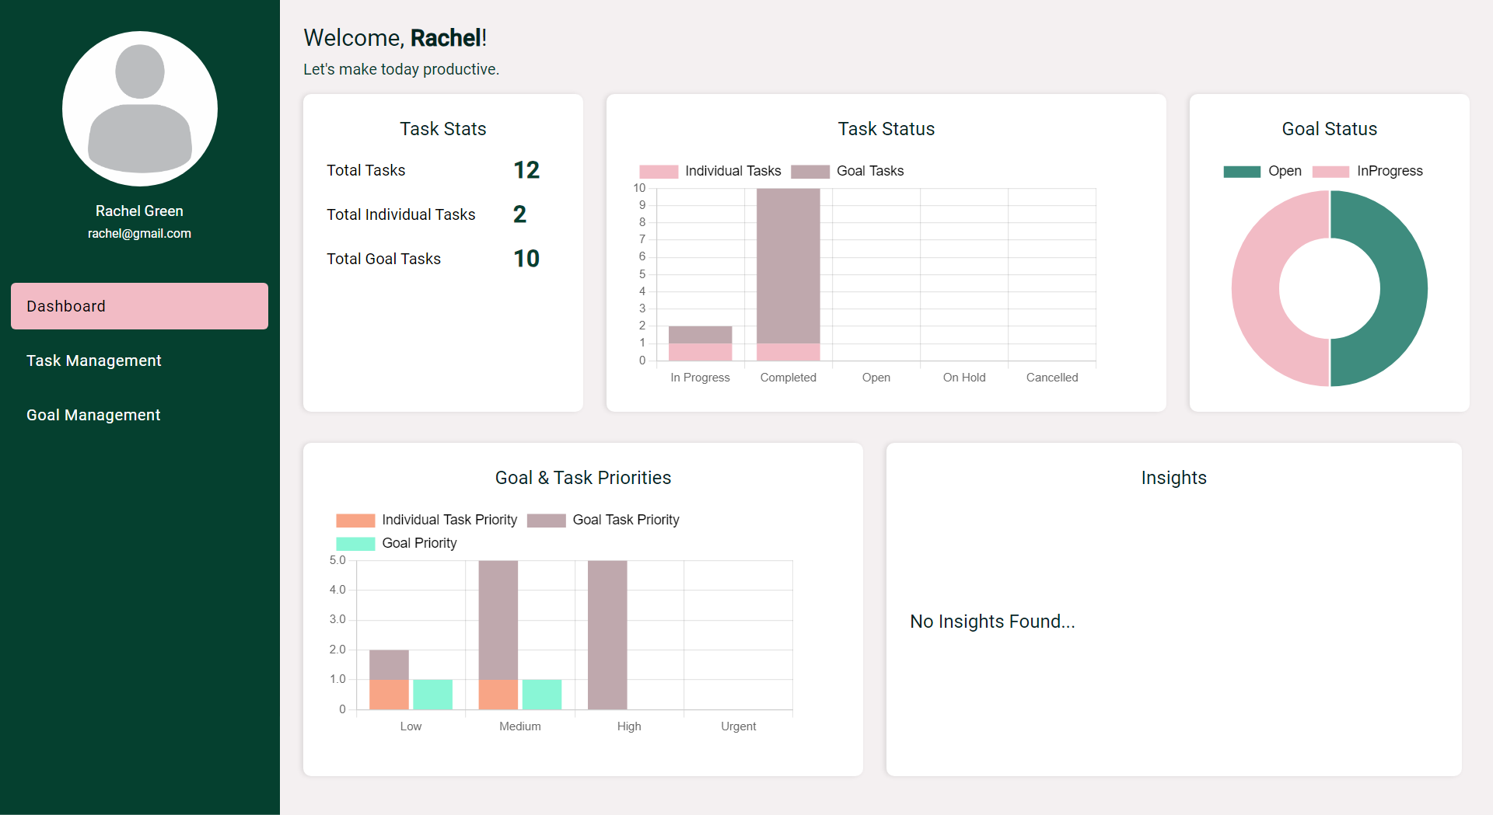

*Figure 27: User Dashboard.*

# CHAPTER 8: CONCLUSIONS AND RECOMMENDATIONS

## 8.1 Conclusion

In conclusion, the "Adaptive Work Management Application for Elevated Productivity" demonstrates the potential of integrating GenAI technology into existing applications to enhance productivity and goal achievement for working professionals. Through the implementation of key modules such as goal setting, the application offers a user-friendly solution aimed at facilitating efficient task management.

Gemini, the chosen GenAI model, plays a pivotal role in providing users with personalized recommendations, ensuring effective task prioritization, and aligning goals with the SMART criteria. However, it is important to acknowledge the limitations associated with emerging GenAI models. While GenAI-based intelligence offers significant potential, there may be instances where it provides inaccurate or unreliable information, particularly during its developmental stages. Therefore, while GenAI integration can enhance application efficiency, it should be complemented with human oversight to ensure reliability and accuracy.

## 8.2 Recommendations

Based on the findings of this research, the following recommendations are proposed:

1. **Continuous Monitoring and Improvement:** Regular monitoring and evaluation of GenAI performance within the application are essential to identify and address any discrepancies or inaccuracies promptly.
2. **User Training and Education:** Providing users with guidance on effectively utilizing GenAI features and understanding its capabilities and limitations can
3. **Hybrid Approach:** Adopting a hybrid approach that combines GenAI-based intelligence with human judgment and intervention can maximize the benefits of AI while mitigating risks associated with potential errors or inaccuracies.
4. **User Feedback Mechanism:** Implementing a feedback mechanism within the application allows users to report any discrepancies or issues encountered while interacting with GenAI features, enabling continuous improvement and optimization.

# CHAPTER 9: APPENDICES

## 9.1 Sample Code Structure

### 9.1.1 WorkWise API

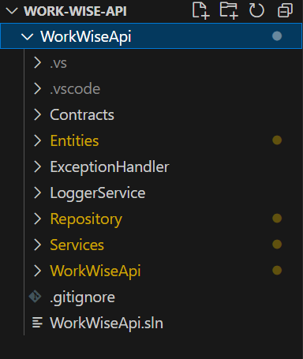

*Figure 28: WorkWise API Code Structure.*

### 9.1.2 WorkWise Web

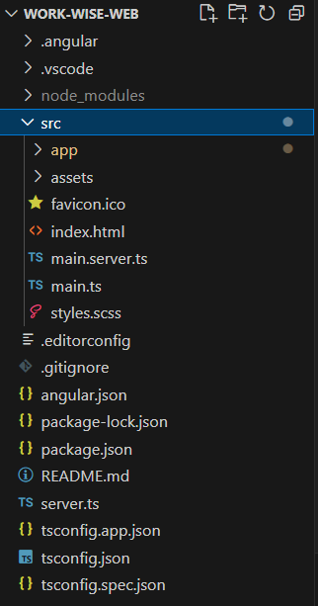

*Figure 29: WorkWise Web Code Structure.*

## 9.2 List of Abbreviations

* **AI**: Artificial Intelligence
* **API**: Application Programming Interface
* **GenAI**: Generative Artificial Intelligence
* **SMART**: Specific, Measurable, Achievable, Relevant, Time-bound
* **SQL**: Structured Query Language
* **SCSS**: Sassy Cascading Style Sheets
* **UI**: User Interface
* **HTTPS**: Hypertext Transfer Protocol Secure
* **JSON**: JavaScript Object Notation
* **SMART**: Specific, Measurable, Achievable, Relevant, Time-bound
* **NPM**: Node Package Manager
* **CLI**: Command Line Interface
* **JWT**: JSON Web Token

# CHAPTER 10: REFERENCES

Below are some of the links referred to,

* <https://ai.google.dev/>
* <https://ai.google.dev/gemini-api/docs>
* <https://jwt.io/>
* <https://www.snaplogic.com/glossary/generative-integration>
* <https://blog.google/technology/ai/gemini-api-developers-cloud/>

# CHAPTER 11: GLOSSARY

1. **Adaptive Work Management Application**: A software application designed to dynamically adjust to users' needs and preferences, optimizing task prioritization and goal setting for enhanced productivity.
2. **GenAI Technology**: Short for General Artificial Intelligence, GenAI refers to artificial intelligence systems that possess broad capabilities, such as learning, reasoning, and problem-solving, akin to human intelligence.
3. **Task Prioritization**: The process of determining the relative importance or urgency of tasks, enabling users to focus on high-priority activities to achieve goals efficiently.
4. **Goal Setting**: The process of establishing specific, measurable, achievable, relevant, and time-bound objectives to guide and evaluate progress towards desired outcomes.
5. **Gemini (GenAI Model)**: A specific GenAI model integrated into the Adaptive Work Management Application, responsible for providing personalized recommendations based on user preferences and historical data.
6. **SMART Criteria**: A mnemonic acronym that stands for Specific, Measurable, Achievable, Relevant, and Time-bound, used to guide effective goal setting and ensure objectives are well-defined and attainable.
7. **Web Application**: An application software that runs on web browsers, accessible over the internet, allowing users to interact with it through a graphical user interface.
8. **Database**: A structured collection of data organized in a manner that facilitates efficient storage, retrieval, and manipulation of information, typically stored in tables consisting of rows and columns.
9. **Web API Application**: A web-based application programming interface (API) that allows communication between different software applications over the internet, enabling data exchange and interoperability.
10. **Integration:** The process of combining different components or systems to work together seamlessly, often involving the exchange of data and functionalities.

**Checklist of Items for the Final Dissertation / Project / Project Work Report**

This checklist is to be attached as the last page of the final report.

**This checklist is to be duly completed, verified and signed by the student.**

|  |  |  |
| --- | --- | --- |
|  | **Is the final report neatly formatted with all the elements required for a technical Report?** | **Yes** |
|  | Is the Cover page in proper format as given in Annexure A? | **Yes** |
|  | Is the Title page (Inner cover page) in proper format? | **Yes** |
|  | (a) Is the Certificate from the Supervisor in proper format?  (b) Has it been signed by the Supervisor? | **Yes**  **Yes** |
|  | Is the Abstract included in the report properly written within one page? Have the technical keywords been specified properly? | **Yes**  **Yes** |
|  | Is the title of your report appropriate? **The title should be adequately descriptive, precise and must reflect scope of the actual work done.** Uncommon abbreviations / Acronyms should not be used in the title | **Yes** |
|  | Have you included the List of abbreviations / Acronyms? | **Yes** |
|  | Does the Report contain a summary of the literature survey? | **Yes** |
|  | Does the Table of Contents include page numbers?   1. Are the Pages numbered properly? (Ch. 1 should start on Page # 1) 2. Are the Figures numbered properly? (Figure Numbers and Figure Titles should be at the bottom of the figures) 3. Are the Tables numbered properly? (Table Numbers and Table Titles should be at the top of the tables) 4. Are the Captions for the Figures and Tables proper? 5. Are the Appendices numbered properly? Are their titles appropriate | **Yes**  **Yes**  **Yes**  **Yes**  **Yes**  **Yes** |
|  | Is the conclusion of the Report based on discussion of the work? | **Yes** |
|  | Are References or Bibliography given at the end of the Report?  Have the References been cited properly inside the text of the Report?  Are all the references cited in the body of the report | **Yes**  **Yes**  **Yes** |
|  | Is the report format and content according to the guidelines? The report should not be a mere printout of a PowerPoint Presentation, or a user manual. Source code of software need not be included in the report. | **Yes** |

**Declaration by Student:**

I certify that I have properly verified all the items in this checklist and ensure that the report is in proper format as specified in the course handout.

**Place: Chennai Signature of the Student**

**Date: 29th April 2024 Name: Pavithra S**

**ID No.: 2022MT93172**